**Facebook and Instagram could be shut down in Europe, according to Meta.**

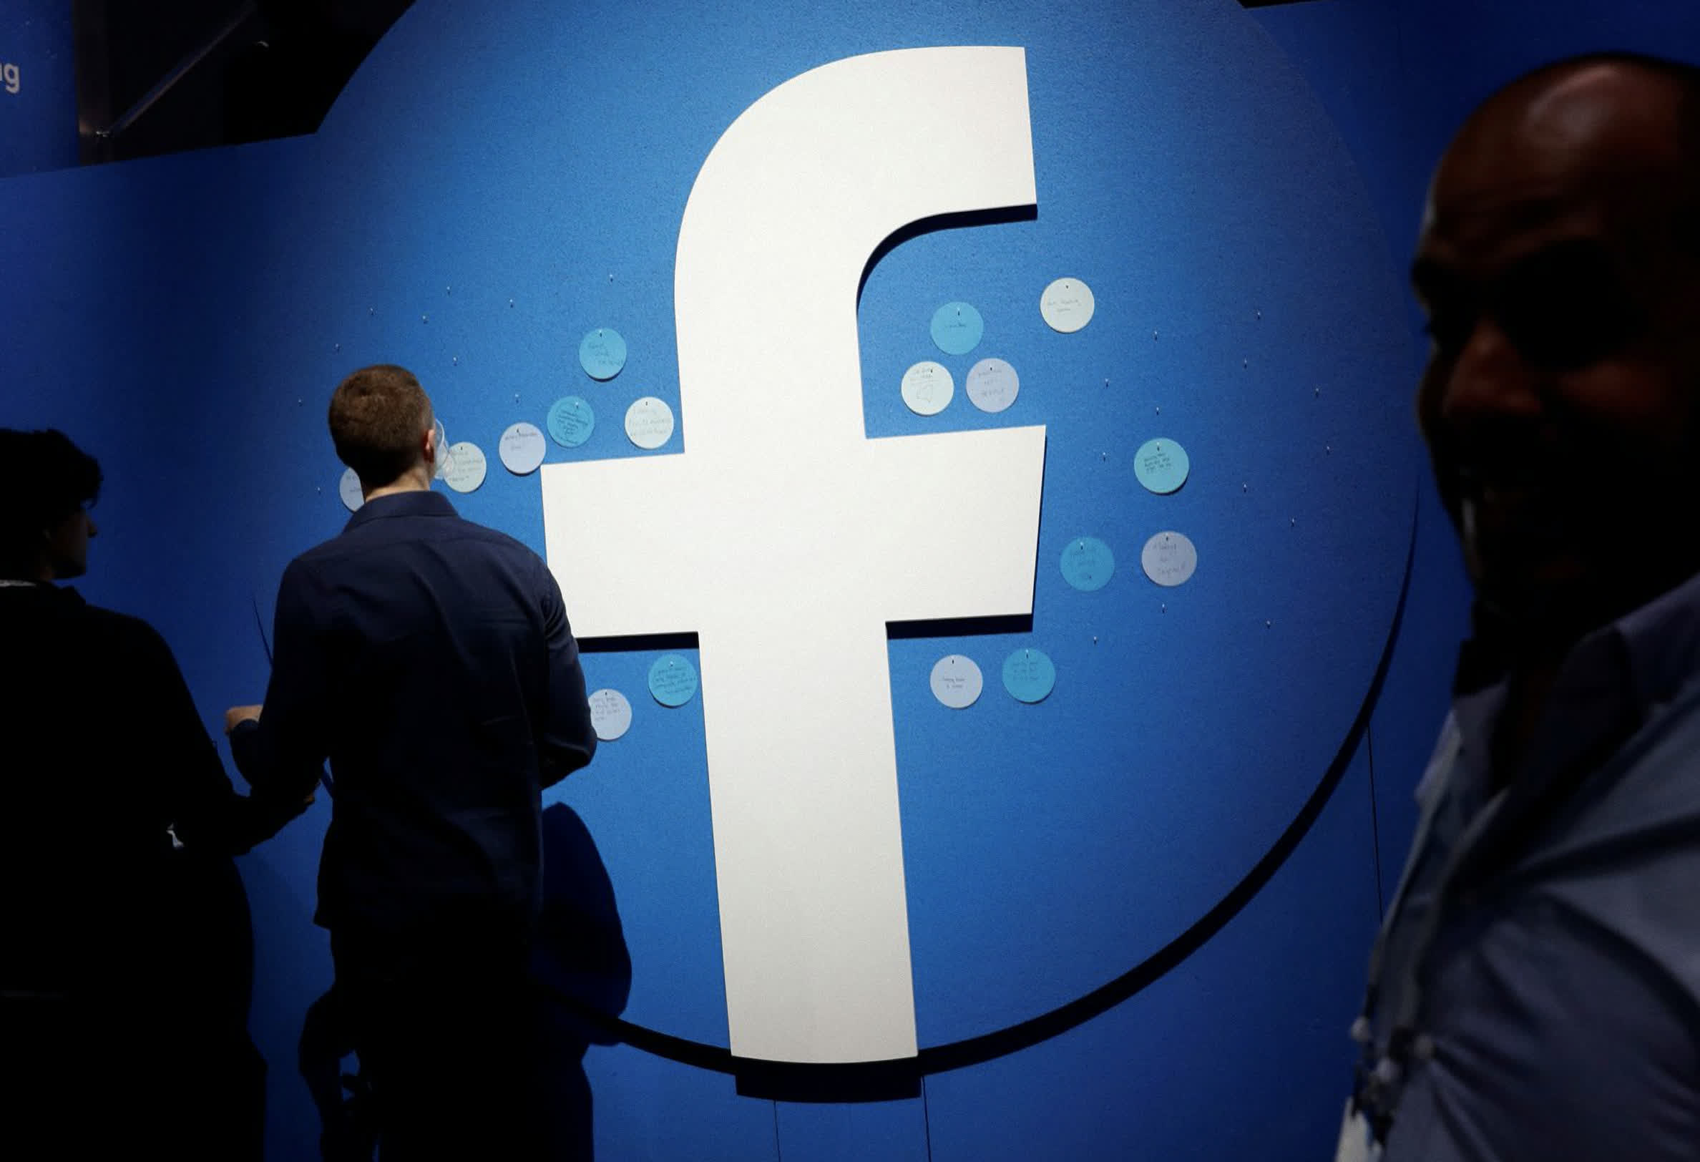

In context, Meta has threatened to shut down Facebook and Instagram in Europe if it is not permitted to transport, store, and process user data on its servers in the United States. If this were to happen, it would have a major impact on Meta's business and bottom line, since it would affect hundreds of millions of social media users across its two prominent platforms.

CityAM, a London financial newspaper, reports that Meta used Privacy Shield, a transatlantic data transfer framework, to transfer European users' data from Europe onto US servers. However the treaty was canceled in 2020 due to data privacy violations. Meta also uses agreements to facilitate transatlantic transfers and store European user data in the US. However, these agreements are also being scrutinized by regulators.

Meta stated in its annual report to US securities and exchange commission that "if we are unable or restricted from sharing data among products or services, or between countries or regions, it could impact our ability or ability to provide services, the way we provide them, or our ability target ads."

Meta continues to state that it is confident it can reach agreements by 2022. However, if current agreements are not used or similar alternatives are taken away, Meta will "likely" be unable to offer some of our most important products and services in Europe.

Meta's Vice President of Global Affairs and Communications Nick Clegg told CityAM that a lack of international data transfers was a threat to the economy and would hinder the growth of data-driven companies in the EU. This is just like we are seeking a recovery from Covid-19.

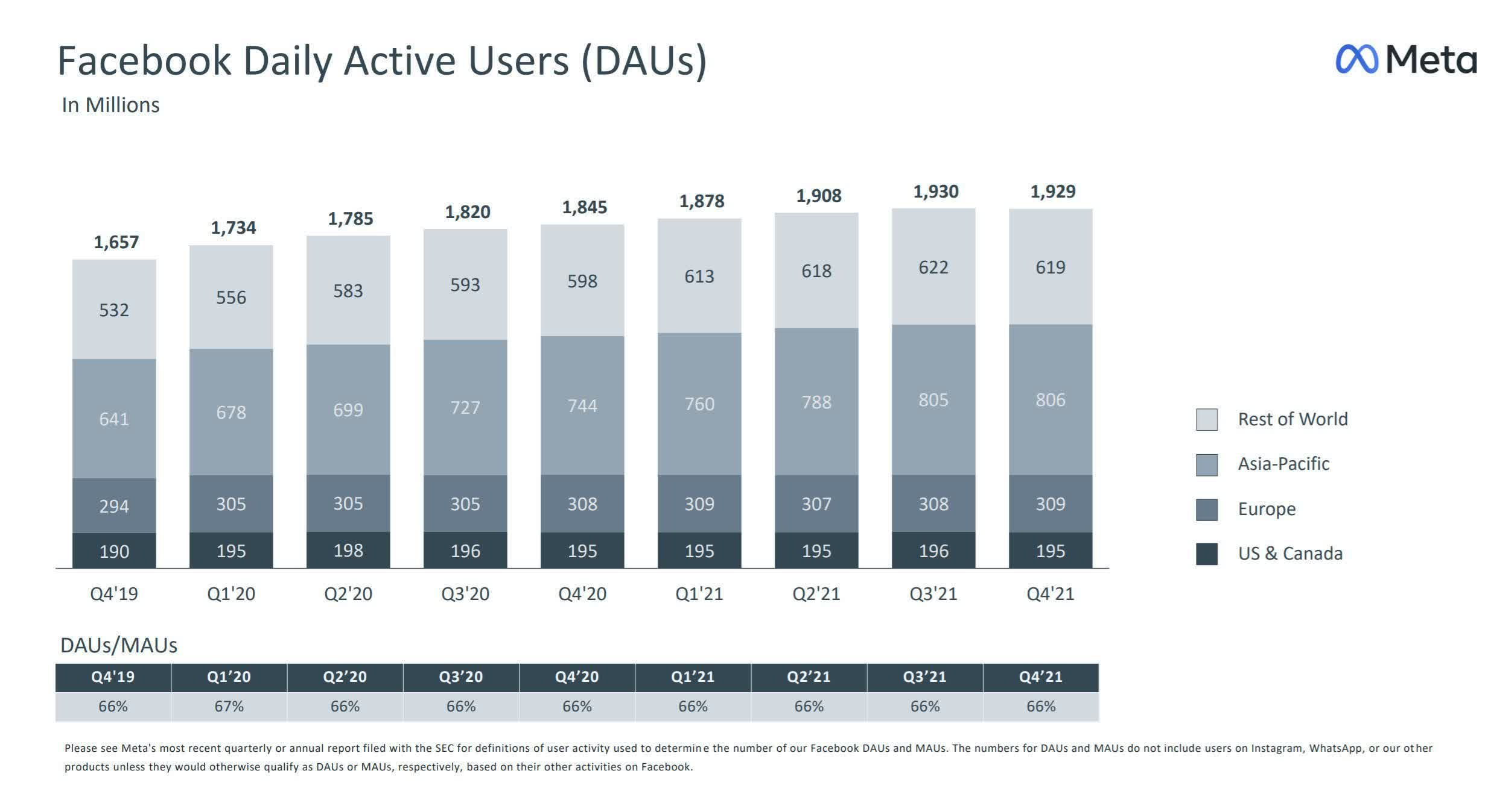

Meta's shares [suffered a beating](https://www.techspot.com/news/93244-facebook-shares-plunge-20-after-daily-user-numbers.html) last Wednesday after user numbers dropped for the first-ever time, wiping out billions of its value. This makes it seem like FB and Instagram are unlikely to shut down in Europe. Meta will not want to lose any of that potential revenue, and it may even spook investors. Facebook alone boasts 309 million active users per day in Europe.

A Facebook spokesperson stated that they have no intention or plans to leave Europe. However, Meta and many other organizations, businesses, and services rely on data transfers between the US and EU to provide global services.

"Fundamentally businesses require clear, global rules that protect transatlantic data flows over long-term. We are closely following the developments in Europe as they progress, like more than 70 companies from a broad range of industries.